The Standard Module

The standard module is the form factor that governs the design of USC. Each module follows this same basic body plan.

It is 115mm square, with holes that are 4.875mm in diameter and 99mm apart from their centers, and 5mm thick. The hole diameter is a function of the diameter of the neodymium magnets, the flexibility of the medium (typically acrylic), and the thickness and settings of the laser. It is advised to do a test cut first to guarantee a proper friction fit.

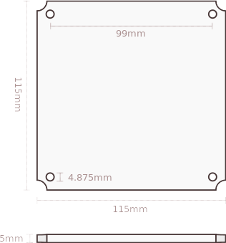

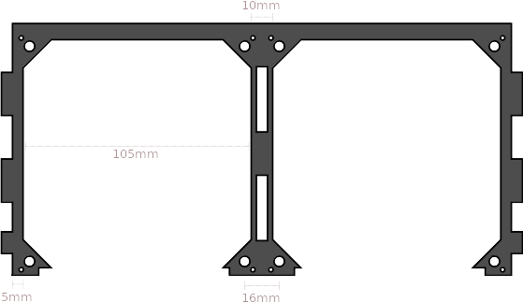
The module fits into the Module Slot. They have the same holes for magnets, 16mm apart where the modules touch. The slots are 105mm square, with a 5mm edge (or 10mm between them).
Containers

Containers are the larger units of USC. They may have up to 8 module slots and as few as 1.

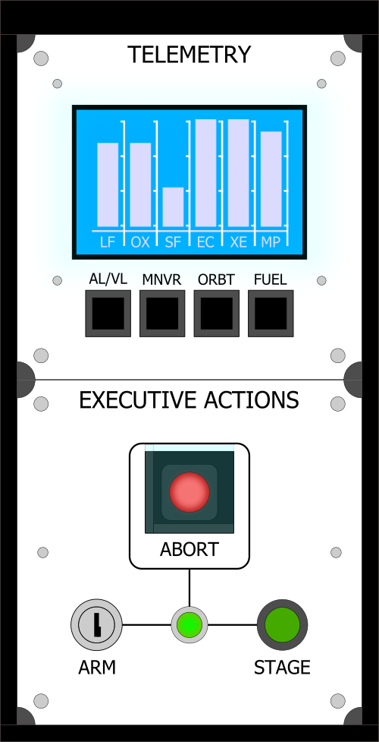

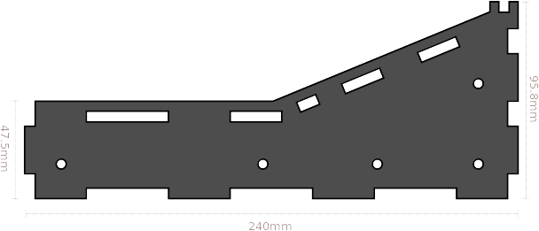
Containers have several measurements in common. Their pieces should all be 5mm thick. They are all 95.8mm tall on the back end. Containers that are two modules deep are 240mm long and 47.5mm tall on the short end. The measurements throughout the containers may not be exact; typically they are a few fractions of a millimeter shorter in order to account for the space needed for the caulk adhesive.

